Elements, Compounds, and Mixtures

Introduction
Elements are the simplest and most basic forms of matter. Elements cannot be broken down into any simpler substance – all known matter in the universe is made of elements.

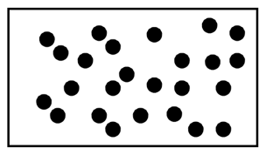
Some elements are made up of single, individual atoms. Very few atoms exist like this however as most atoms react with other atoms. The only atoms which do not react and thus exist as single atoms are the “noble” gases, such as Helium, Neon, Argon etc. (The right hand column of the operiodic table)

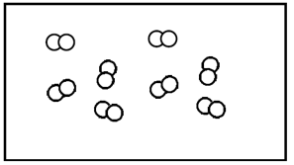
Molecules are formed when two or more atoms chemically bond together. Most elements form molecules, so molecules are extremely common. Some elements (such as the gases oxygen and nitrogen for example) form molecules with other atoms of the same type. Thus while oxygen is an element, it is found in nature as molecules of two oxygen atoms joined together (O₂). In the examples on the right, the elements are composed of only one type of atom.

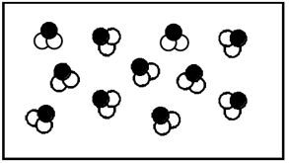
Compounds are formed when different types of atoms join together – thus compounds are molecules with different elements in the molecule. An example is H₂O, which is made from 2 hydrogen and 1 oxygen atoms joined together in a molecule. Another example is HCl, which is 1 hydrogen and 1 Chlorine atom bonded together.

Not all substances are elements and compounds however. Both elements and compounds are pure substances. Sometimes when elements or compounds are placed together they do not chemically react and bond to each other.
A mixture is when pure substances exist together but are not chemically bonded together. Milk is an example of a mixture, so is Air, and soil.

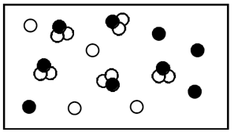
Homogeneous mixtures are uniform – they have the same composition throughout.

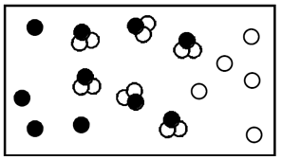
Heterogeneous mixtures are not uniform. Some areas may have higher or lower concentrations of the individual substances.

Practice - For each of the examples below,
- indicate whether they are pure substances, homogeneous mixtures, or heterogeneous mixtures.
- If a pure substance, label it as a compound or element. If a mixture, indicate whether elements, compounds, or both are present.
- Finally, place a check in the boxes if molecules or atoms (or both) are present and if elements or compounds (or both) are present.

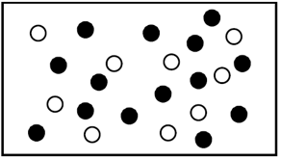 | This is a _________________________________________  an element / a compound / elements / compounds  pure substances / homogeneous mixture / heterogeneous mixture  composed of _____________________________________.  Which is present? □ Molecules □ Atoms  □ Elements □ Compounds
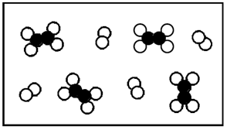 | This is a _________________________________________  an element / a compound / elements / compounds  pure substances / homogeneous mixture / heterogeneous mixture  composed of _____________________________________.  Which is present? □ Molecules □ Atoms  □ Elements □ Compounds
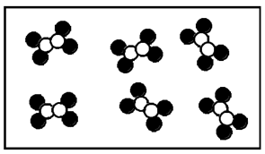 | This is a _________________________________________  an element / a compound / elements / compounds  pure substances / homogeneous mixture / heterogeneous mixture  composed of _____________________________________.  Which is present? □ Molecules □ Atoms  □ Elements □ Compounds
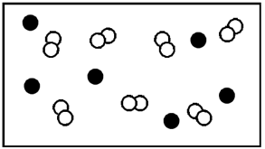 | This is a _________________________________________  an element / a compound / elements / compounds  pure substances / homogeneous mixture / heterogeneous mixture  composed of _____________________________________.  Which is present? □ Molecules □ Atoms  □ Elements □ Compounds
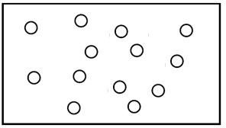 | This is a _________________________________________  an element / a compound / elements / compounds  pure substances / homogeneous mixture / heterogeneous mixture  composed of _____________________________________.  Which is present? □ Molecules □ Atoms  □ Elements □ Compounds

